**OpenGL/GLUT Project in code::block**

TO create OpenGL/GLUT Project in code::block,at first you have to download the glut libary from this website <http://www.deannicholls.co.uk/site/files/glut.zip>  for windows.  
  
Lets create GLUT project  
**step 1:**  
 first unzip the zip file

**step 2:**  
 a. copy the glut.h file from the folder of unzip file of step 1  
 and paste to the folder "C:\Program Files\CodeBlocks\MinGW\include\GL"   
 b. again copy libglut32.a file from the folder of unzip file of step 1

and paste to the folder "C:\Program Files\CodeBlocks\MinGW\lib"   
 c. also copy the glut.dll file from the unzip file and

paste it inside "C:\Windows\System32" floder.  
  
  
  
**step 3:**  
 Open the code block you will see window as below and click on create new    
 porject link

[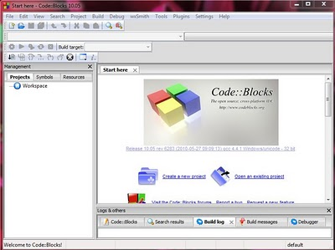](http://3.bp.blogspot.com/-IdZu_4DChUo/TWOW1N_vItI/AAAAAAAAABs/h8Ibm4p9Oco/s1600/start1.JPG)

**step 4:**  
 click on GLUT project as shown in image below  
 click next

[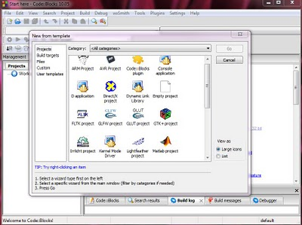](http://2.bp.blogspot.com/-u5B5bIpQ2Yk/TWOWQXKzVFI/AAAAAAAAABU/BBlLsLUYnpo/s1600/start1.JPG)

Enter project title name, give path to save project and project file name is created by default from project title name.

[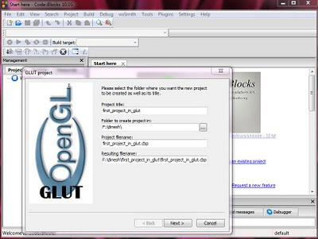](http://2.bp.blogspot.com/-tUznr2rlYl0/TWOWUwDvgLI/AAAAAAAAABY/VPR8SqzjNHE/s1600/start2.JPG)

After that click next.  
  
  
**Step 5:**  
 now give the path "C:\Program Files\CodeBlocks\MinGW" for glut location

[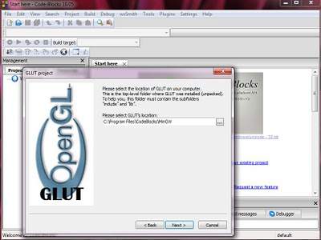](http://2.bp.blogspot.com/-qP_fztLVbdk/TWOWYnOzntI/AAAAAAAAABc/udNY3grqOLI/s1600/start3.JPG)

Then click next.

[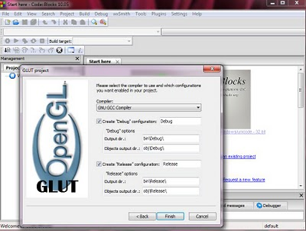](http://2.bp.blogspot.com/-t4LkrBVFuLc/TWOWdHGIcBI/AAAAAAAAABg/bLEBzGvWZBU/s1600/start4.JPG)

Now click finish

**step 6:**

[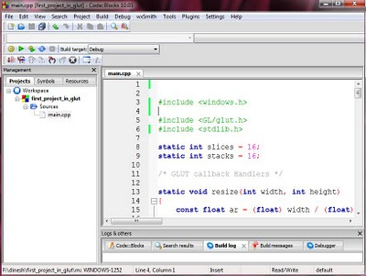](http://1.bp.blogspot.com/-qx_mackM8A4/TWOWjICxnYI/AAAAAAAAABk/PDWLyNQZbzo/s1600/start5.JPG)

Finally project is created and you will get default main.cpp file and don't forget to write  "#include<GL/gl.h> and #include<windows.h>" header file otherwise you may get error now built and run it will see window as below.

[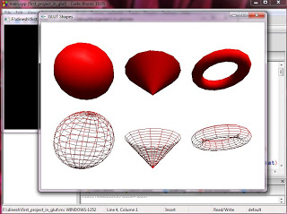](http://2.bp.blogspot.com/-2BRgx8Si_U0/TWOWlv9iVEI/AAAAAAAAABo/qJsrCexkZQ0/s1600/start6.JPG)

If you see the output of your program as above image then you have successfully   
created a project.